**Université Abdelmalek Essaâdi**

**Faculté des Sciences et Techniques-Tanger**

**Département Génie Informatique**

[**Cryptographie-Sécurité Services**](https://classroom.google.com/c/NjY1MDU4MTM5NTAy)

Zone-Based Policy Firewall-2



Réalisé Par :

Yossra safi chetouan

***LAB : Packet Tracer-Configuring a Zone-Based Policy Firewall (ZPF)***

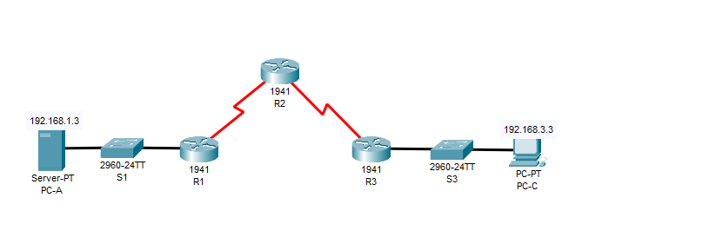

***Part 1: Verify Basic Network Connectivity***

Verify network connectivity prior to configuring the zone-based policy firewall.

Step 1: From the PC-A command prompt, ping PC-C at 192.168.3.3.

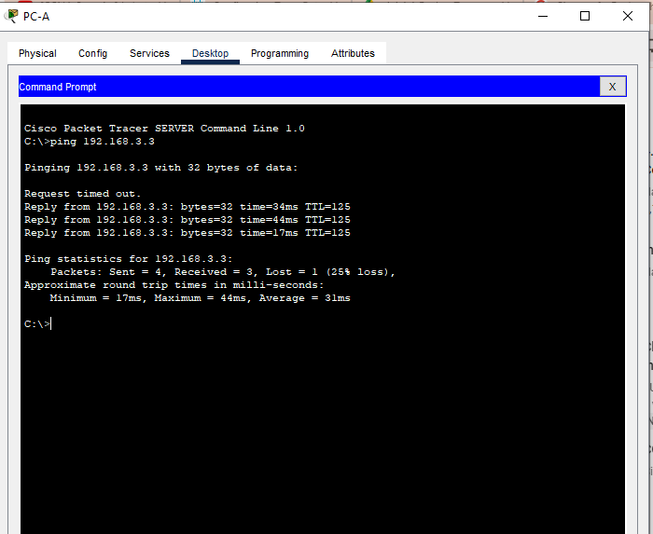

Step 2: Access R2 using SSH.

a. From the PC-C command prompt, SSH to the S0/3/1 interface on R2 at 10.2.2.2. Use the username

Admin and password Adminpa55 to log in.

PC>ssh -l Admin 10.2.2.2

b. Exit the SSH session.

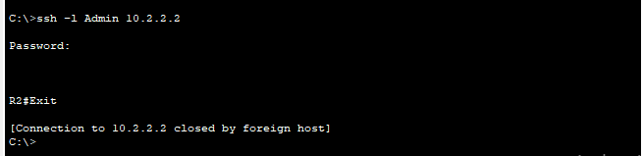

Step 3: From PC-C, open a web browser to the PC-A server.

a. Click the Desktop tab and then click the Web Browserapplication. Enter the PC-A IP address

192.168.1.3 as the URL. The Packet Tracer welcome page from the web server should be displayed.

b. Close the browser on PC-C.

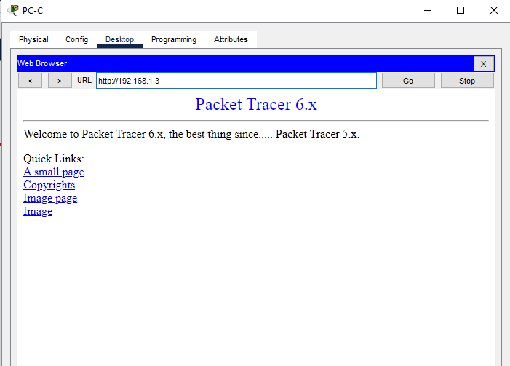

***Part 2: Create the Firewall Zones on R3***

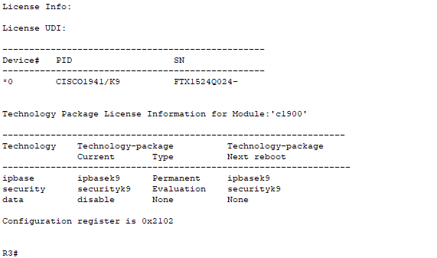

Step 1: Create an internal zone.

Use the zone security command to create a zone named IN-ZONE.

R3(config)# zone security IN-ZONE

R3(config-sec-zone) exit

Step 3: Create an external zone.

Use the zone security command to create a zone named OUT-ZONE.

R3(config-sec-zone)# zone security OUT-ZONE

R3(config-sec-zone)# exit

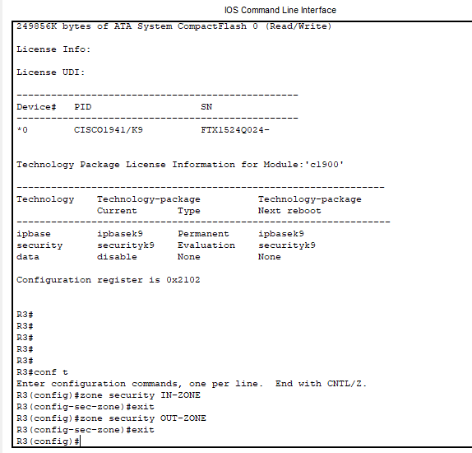

***Part 3: Identify Traffic Using a Class-Map***

Step 1: Create an ACL that defines internal traffic.

Use the access-list command to create extended ACL 101 to permit all IP protocols from the 192.168.3.0/24

source network to any destination.

R3(config)# access-list 101 permit ip 192.168.3.0 0.0.0.255 any

Step 2: Create a class map referencing the internal traffic ACL.

Use the class-map type inspect command with the match-all option to create a class map named IN-NET-

CLASS-MAP. Use the match access-group command to match ACL 101.

R3(config)# class-map type inspect match-all IN-NET-CLASS-MAP

R3(config-cmap)# match access-group 101

R3(config-cmap)# exit

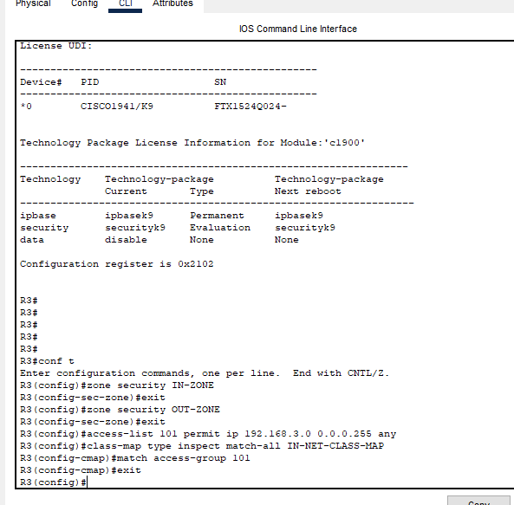

***Part 4: Specify Firewall Policies***

Step 1: Create a policy map to determine what to do with matched traffic.

Use the policy-map type inspect command and create a policy map named IN-2-OUT-PMAP.

R3(config)# policy-map type inspect IN-2-OUT-PMAP

Step 2: Specify a class type of inspect and reference class map IN-NET-CLASS-MAP.

R3(config-pmap)# class type inspect IN-NET-CLASS-MAP

Step 3: Specify the action of inspect for this policy map.

R3(config-pmap-c)# inspect

R3(config-pmap-c)# exit

R3(config-pmap)# exit

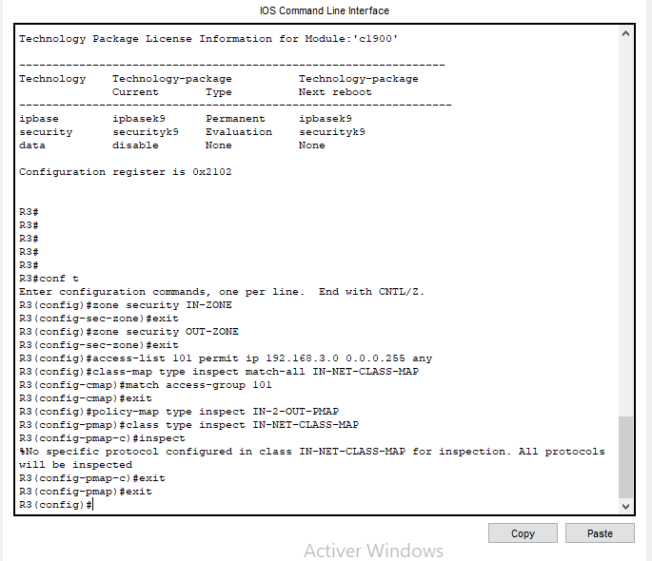

***Part 5: Apply Firewall Policies***

Step 1: Create a pair of zones.

Using the zone-pair security command, create a zone pair named IN-2-OUT-ZPAIR. Specify the source and

destination zones that were created in Task 1.

R3(config)# zone-pair security IN-2-OUT-ZPAIR source IN-ZONE destination OUT-ZONE

Step 2: Specify the policy map for handling the traffic between the two zones.

Attach a policy-map and its associated actions to the zone pair using the service-policy type inspect

command and reference the policy map previously created, IN-2-OUT-PMAP.

R3(config-sec-zone-pair)# service-policy type inspect IN-2-OUT-PMAP

R3(config-sec-zone-pair)# exit

R3(config)#

Step 3: Assign interfaces to the appropriate security zones.

Use the zone-member security command in interface configuration mode to assign F0/1 to IN-ZONE and

S0/3/1 to OUT-ZONE.

R3(config)# interface f0/1

R3(config-if)# zone-member security IN-ZONE

R3(config-if)# exit

R3(config)# interface s0/3/1

R3(config-if)# zone-member security OUT-ZONE

R3(config-if)# exit

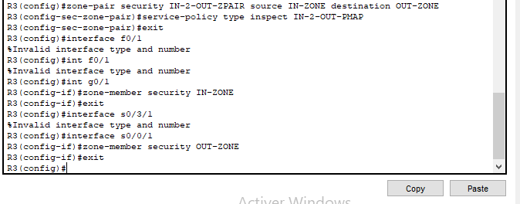

***Part 6: Test Firewall Functionality from IN-ZONE to OUT-ZONE***

Verify that internal hosts can still access external resources after configuring the ZPF.

Step 1: From internal PC-C, ping the external PC-A server.

From the PC-Ccommand prompt, ping PC-A at 192.168.1.3. The ping should succeed.

Step 2: From internal PC-C, SSH to the R2 S0/3/1 interface.

From the PC-Ccommand prompt, SSH to R2 at 10.2.2.2. Use the username Admin and the password

Adminpa55 to access R2. The SSH session should succeed.

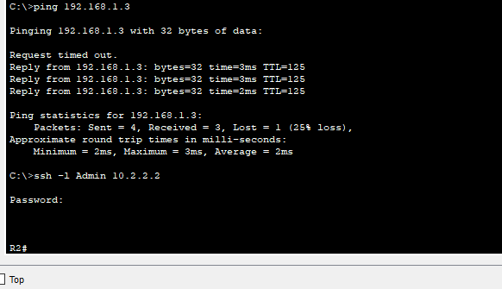

***Part 7: Test Firewall Functionality from OUT-ZONE to IN-ZONE***

Verify that external hosts CANNOT access internal resources after configuring the ZPF.

Step 1: From the PC-A server command prompt, ping PC-C.

From the PC-Acommand prompt, ping PC-C at 192.168.3.3. The ping should fail.

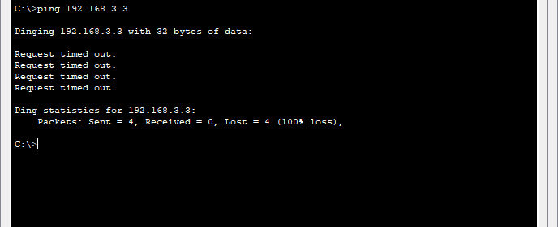

Step 2: From R2, ping PC-C.

From R2, ping PC-C at 192.168.3.3. The ping should fail.

